Model Evaluation

Model Selection
- What it is: Choosing the best model or algorithm for your problem from a set of candidates.
- Goal: Find the model that is likely to perform best on unseen data.
- How it's done: Compare models using techniques like cross-validation, hyperparameter tuning, or testing different algorithms.
- Example: Deciding whether to use a decision tree, logistic regression, or a neural network for your classification task.

Model Evaluation
- What it is: Measuring how well your chosen model performs.
- Goal: Quantify the model's accuracy, precision, recall, etc., to ensure it meets your requirements.
- How it's done: Use metrics like accuracy, F1 score, RMSE, or AUC-ROC on a validation or test dataset.
- Example: Checking if your neural network achieves over 90% accuracy on your test data.

Model Selection and Model Evaluation in terms of train/test data sets and their role in ensuring model performance.

Key Points:
- Model Selection:
  - Focuses on choosing the best model from multiple candidates.
  - It involves training and testing models on subsets of your dataset (e.g., train/test split).
  - The model that best fits the training and validation data (not overfitting or underfitting) is selected.
- Model Evaluation:
  - Once the model is selected, it is tested on unseen (test) data to check its generalization ability (how well it performs on data it hasn’t seen before).
  - Evaluation focuses on metrics (e.g., accuracy, precision, etc.) to validate consistency and avoid overfitting issues.
- Generalization:
  - The ability of a model to perform well on unseen data is referred to as generalization, and this is the essence of model evaluation.
- Train/Test Data Set:
  - Train Set: Used to train the model and fit its parameters.
  - Test Set: Used to evaluate how well the selected model generalizes to new, unseen data.
A model performing well during selection may overfit, so proper evaluation on the test set ensures it truly generalizes.

Regression models
MAPE, RMSE, and RMSLE for regression models, along with examples of when to use each:

1. Mean Absolute Percentage Error (MAPE)

What it is:
- Measures the percentage error between predicted and actual values.
- Formula:
- It's useful for understanding how big the errors are in relation to the true values.

Use Case:
- Use MAPE when you want to express the error as a percentage (easy to interpret).
- Example: Forecasting sales or revenue where percentage error is more meaningful than raw differences.

Limitations:
- Doesn't work well if the actual values are close to zero (division by small numbers inflates error).

2. Root Mean Squared Error (RMSE)

What it is:
- Measures the square root of the average squared errors.
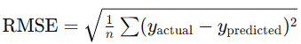
- Formula: ​
- Penalizes large errors more heavily than smaller ones because of squaring.

Use Case:
- Use RMSE when large errors are particularly undesirable.
- Example: Predicting house prices where a big error (e.g., $100,000 off) is a bigger concern than smaller errors.

Limitations:
- RMSE is in the same units as the data, so it may be harder to interpret without context.

3. Root Mean Squared Logarithmic Error (RMSLE)

What it is:
- Similar to RMSE but works with the logarithm of the predicted and actual values.
- Formula: ​
- Focuses more on relative differences rather than absolute ones.

Use Case:
- Use RMSLE when you care about relative percentage differences and want to reduce the impact of large values.
- Example: Predicting population growth or income where large values dominate the dataset.

Limitations:
- Assumes all values are non-negative (logarithms are undefined for negatives).

Summary of When to Use Them

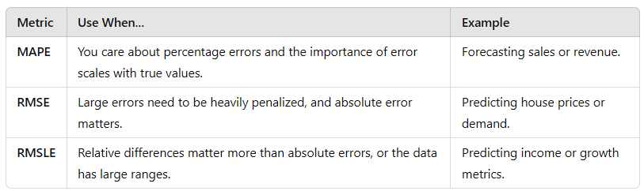

Classification models

In classification problems, different validation metrics are used because the focus is on categorical predictions (e.g., "Yes" or "No," "Spam" or "Not Spam") rather than continuous values. Here's an overview of the key classification metrics and their use cases:

1. Confusion Matrix
- What it is: A table that shows the counts of correct and incorrect predictions for each class.
  - True Positives (TP): Correctly predicted positives.
  - True Negatives (TN): Correctly predicted negatives.
  - False Positives (FP): Predicted positive when it's actually negative (Type I error).
  - False Negatives (FN): Predicted negative when it's actually positive (Type II error).
- Use Case: Great for understanding the breakdown of model predictions, especially when the dataset is imbalanced.
- Example:
  - For a spam email classifier:
    - TP: Spam email predicted as spam.
    - FP: Non-spam email predicted as spam.
    - FN: Spam email predicted as non-spam.

2. Receiver Operating Characteristics (ROC) Curve
- What it is: A plot that shows the trade-off between:
  - True Positive Rate (Recall): TP / TP+FN​
  - False Positive Rate: FP / FP+TN​
- Purpose: Helps visualize how well the model separates the classes at different threshold values.
- Use Case: Use it to compare classifiers and understand their performance across thresholds.
- Example: In a medical diagnosis model, an ROC curve shows how changing the threshold affects the detection of diseases versus false alarms.

3. Area Under Curve (AUC)
- What it is: The area under the ROC curve, summarizing the model's performance into a single number.
  - AUC = 1: Perfect classifier.
  - AUC = 0.5: Random guess.
- Use Case: Use AUC to evaluate and compare models based on their ability to distinguish between positive and negative classes.
- Example: For a cancer prediction model, a high AUC means the model effectively separates cancerous and non-cancerous cases.

4. F1 Score
- What it is: The harmonic mean of Precision and Recall.
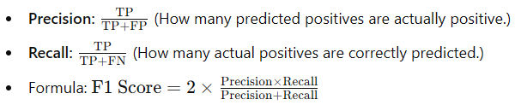
​
- Purpose: Balances Precision and Recall, especially useful when there's a class imbalance (e.g., rare events).
- Use Case: Use F1 Score when false negatives and false positives have different consequences.
- Example: In fraud detection:
  - Precision is important to avoid flagging genuine transactions as fraud (FP).
  - Recall is critical to ensure fraudulent transactions aren’t missed (FN).

When to Use Each Metric
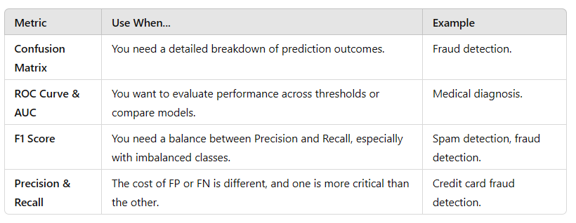
These metrics are complementary, and the best choice depends on the problem, class distribution, and the importance of false positives versus false negatives.

